We will have opportunities to create firework pictures (EAD)

We will go on a forest walk and make leaf pictures (UW/EAD)

We will have opportunities to discuss the changes which occur in Autumn (UW)

We will have opportunities to make a non-fiction book about the hedgehog (LIT)

We will use resources to develop our fine motor skills (PD)

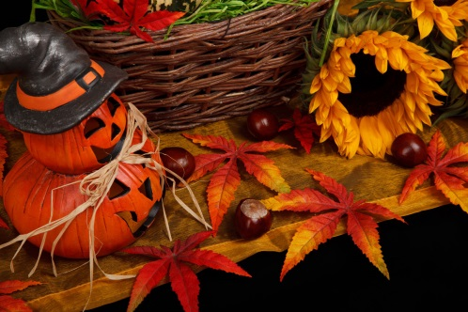

We will have opportunities to learn about autumn animals (UW)

We will have opportunities to engage in role-play and sing songs

(CL/EAD)

We will have opportunities to paint with autumn colours

(EAD)

We will take part in a Christmas play and do lots of Christmas activities (EAD/UW)

We will listen to many autumn themed stories (CL/L)

**Books that we will be using to help our learning:**

**Herbie’s Big Adventure**

**Jennie Doh**

**Hedgehogs**

**Sally Morgan**

**The Story of Christmas**

**The Acorn**

Edward Gibbs

**Signs of Autumn**

Paul Humphrey

**Squirrels Autumn Search**

Anita Loughrey

**Key Words:**

Autumn

Halloween

Bonfire Night

Christmas

Season

Hibernate

Nocturnal

**Other things that we will be learning:**

* Continue to have opportunities to recite numbers in order to 10 and beyond.
* Continue to count objects by saying one number name for each item.
* Using resources to develop our fine motor skills
* Building our knowledge of Makaton signs
* Focusing on managing our emotions
* To have opportunities to write during activities such as role-play activities.
* Continue to have opportunities to recognise and write own name.

