**Phonics**

**I will be recapping all the sounds I have learnt in Phase three.**

**I will be beginning to learn new sounds from Phase five.**

**Maths**

**I will be working on my number fluency.**

**I will be working on counting, forwards and backwards, across 100.**

**I will be working on representing numbers in different ways.**

**Key Vocabulary**

**Body Parts; Head, Shoulders, Knees, Toes, etc.**

**Senses; sight, I see, touch, I feel, smell, I smell, taste, I taste, hear, I hear**

**Family trees**

**Potters Bar, maps, Zepplin, Oakmere, plants, animals**

**England, UK, weather, seasons, Spring, Summer, Autumn, Winter**

**Earth, continents, Seas**

**English**

**I will be working on forming simple and complex sentences.**

**I will be working on sentence structure.**

**I will be working on descriptive writing.**

**I will be working on some non-fiction texts and many stories.**

**PE**

**I will be focusing on travelling in Gymnastics, large ball skills, dance, and throwing, catching and aiming games.**

**Music**

**I will be focusing on using my voice creatively by singing and chanting.**

**I will be developing my listening skills and exploring percussion instruments.**

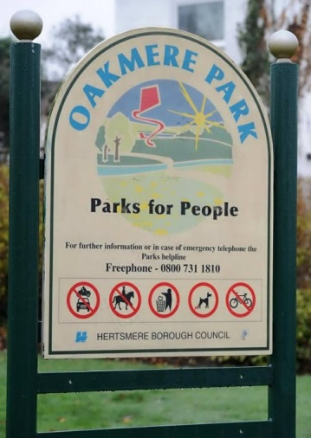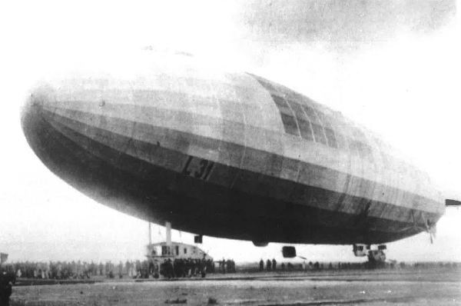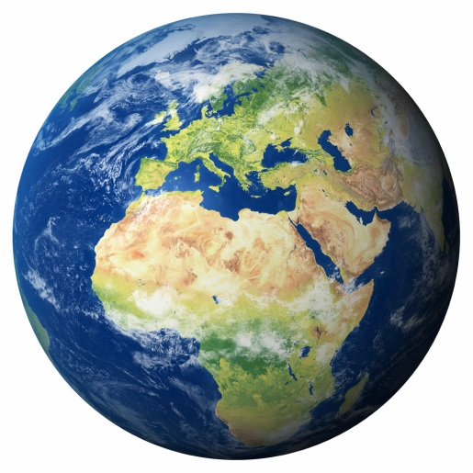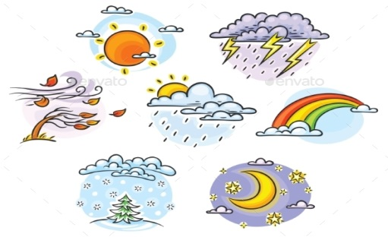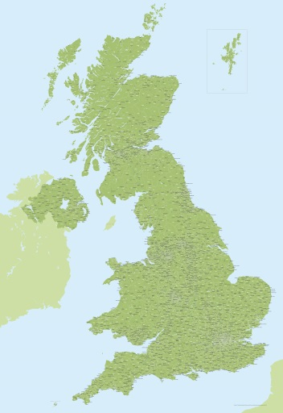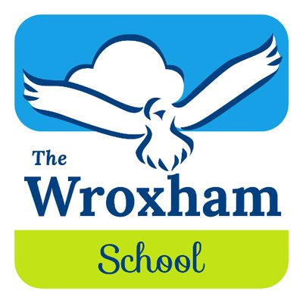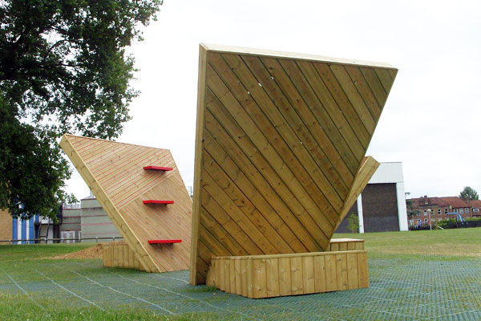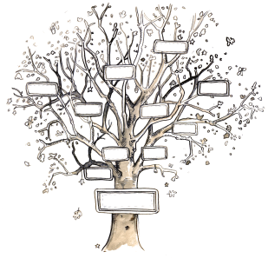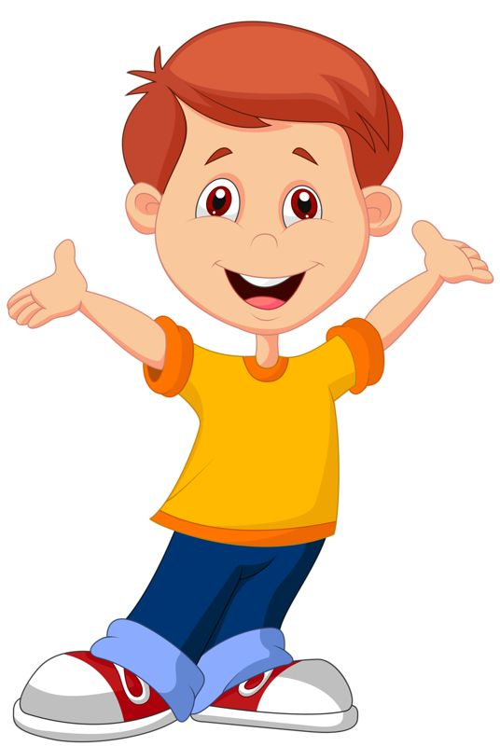

**All About Me**

**ART**

**I will be painting and tracking the different seasons**

**I will be making the Earth & other planets**

**ART**

**I will be drawing and painting my house and my school**

**I will be drawing and making a Zepplin.**

**I will be learning about where I live (Geography).**

**I will be looking at maps of Potters Bar (Geography).**

**I will be learning about the Zepplin crash at Oakmere Park (History & Geography).**

**I will be carrying out basic fieldwork skills in my School and in my local area (Geography).**

**I will be learning about the different animals and plants that live around me (Science).**

**Where will we go next…?**

**I will be learning about the country I live in (Geography).**

**I will be learning about the weather patterns and the seasons in the UK (Science).**

**I will be learning about Earth and the different continents and Seas (Geography).**

**I will be learning all about my body (Science).**

**I will be able to label the different parts of my body (Science).**

**I will be able to talk about my senses (Science).**

**I will be learning about my family tree (History).**

**ART**

**I will be drawing and painting self-portraits.**

**I will be drawing and sculpting my family Trees**