We will have opportunities to discuss our likes and dislikes (PSED CL)

We will practise sharing with our friends (PSED CL)

We will have opportunities to create pictograms about ourselves (M)

We will learn the routines for our classroom

(PSED CL)

We will have opportunities to engage in role play about school (CL EAD)

We will have opportunities to make paper friend people (EAD)

We will have opportunities to create our own maps (UW)

We will learn about what makes a good friend

(PSED CL)

We will learn to make new friends (PSED CL)

We will have opportunities to identify popular places in Potters Bar (UW)

We will have opportunities to create self-portraits (EAD)

We will have opportunities to go on a tour around the school (UW)

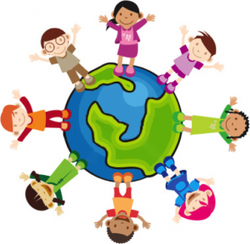

**Books that we will be using to help our learning:**

**Sharing a Shell**

Julia Donaldson

**Elmer**

David McKee

**Snug as a Bug**

Tamsyn Murray

**The Way Back Home**

Oliver Jeffers

**Giraffes Can’t Dance**

Giles Andreae

**A Friend for Little Bear**

Harry Horse

**Mine!**

Rachel Bright

**Monkey Puzzle**

Julia Donaldson

**Other things that we will be learning:**

* Phase 2 phonics, including blending and segmenting to read and write words and phrases
* Using The Numberblocks to develop our mathematical knowledge
* Using 5 and 10 frames to understand the value of numbers and how to represent them using a variety of resources
* Using shapes to make pictures, models and patterns
* PE – using space and moving in different ways
* Using resources to develop our fine motor skills
* Engaging in ‘MindUp’ strategies

**Key Words:**

Share

Friend

Listen

Map

Like

Dislike

