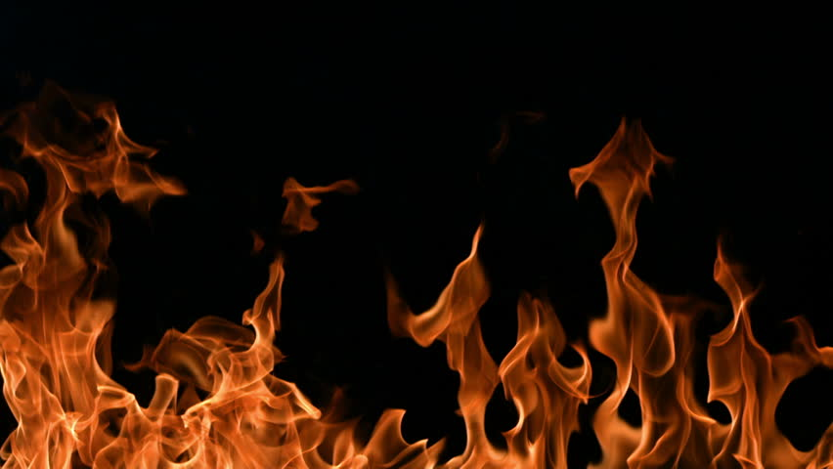



**We will also be learning…**

* **Handwriting**
* **PE – Dance & Games**
* **Computing**
* **Music**
* **Spellings**
* **MindUp**



**Books**

* **Charlie and The Great Fire of London – Sue Finnie**
* **Who was Samuel Pepys? – Paul Harrison**
* **You Wouldn’t Want to be Guy Fawkes – Fiona Macdonald**



**Key Vocabulary**

* **Pudding Lane**
* **King Charles II**
* **River Thames**
* **Samuel Pepys**
* **Treason**
* **King James I**
* **Parliament**





**Year 2**

**Sparks**

**&**

**Embers**

**Autumn**



**Art & DT.**

* **Building 3D houses**
* **Watercolours**
* **Fire Engines**



**History & Geog.**

* **Great Fire of London**
* **Guy Fawkes**



**Phonics**

* **Phase 5 recap**
* **Phase 6**



**Science**

* **Heating and melting**
* **Material uses**
* **Healthy Living**



**English**

* **Diary entries**
* **Descriptions**
* **Newspaper reports**



* **Shape**
* **Operations (+ - x ÷)**
* **Measuring**

**Maths**